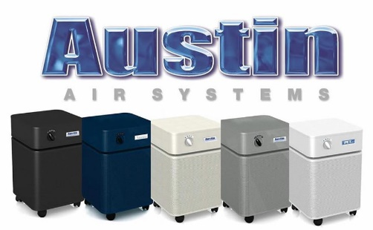
AIR QUALITY
Quote / Call Out Box
The air in our homes has been touted by experts as being some of the most polluted air we breathe. GreenWorks takes this very seriously as it affects your health and the health of your family.

Cleaner Air in Your Home
From today’s super energy-efficient homes that are sealed off from the exterior environment to older homes from the built environment; building material off-gassing, soil gases, home cleaners, paints & varnishes, etc. can build up and degrade our indoor air. Known as Volatile Organic Compounds (VOCs), these toxic gases can collect in your home and grow to concentrations that can make it hard to breathe. GreenWorks can make the air you breathe better!
The Air Quality Rule
Our indoor air should be at least as healthy as our outdoor air (if not better). Just step outside on any good air quality day and take a deep breath – smells nice doesn’t it! Now do the same inside your home. If your indoor air smells different than you’re the outside air there could be a problem. If you don’t smell anything at all, don’t panic! Not being able to smell aromas in the air we breathe is more common than you think.
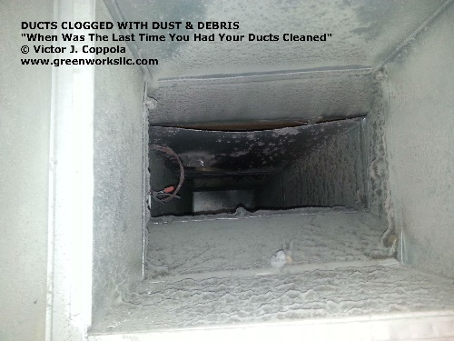
Wondering If the Air In Your Home Is Healthy?
Are family members experiencing things like winter-asthma and over-active sinus to unexplained respiratory illnesses, rashes or brain-fog? Do you feel better when you leave your home only to have symptoms re-appear when your return home? Are your friends and family complaining about itchy / watery eyes, coughing / scratchy throats or inflamed sinuses when they visit? Poor indoor air quality may be to blame! A call to GreenWorks can help get you the answers you are looking for.
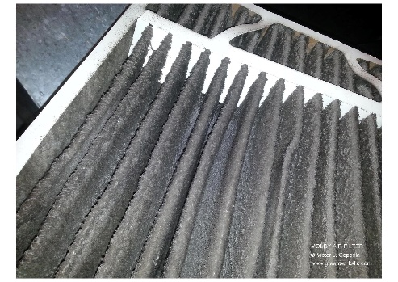
Air Quality Services
- Air Purifiers
- Phase I Environmental Services
- Asbestos Building Inspections
- Lead based Paint
- Allergens
- Chemical Sensitivities
- Ventilators
- Dust & Particulates
- Building Biology
- Material Off-Gassing / VOC’s

