Odor
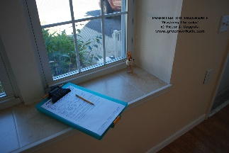
Quote / Call Out Box – Like on the corresponding post card
When you smell smoke there’s always fire! The type of odor you smell (biological / chemical / organic) often ties directly back to a hidden problem. Don’t wait for the fire, call GreenWorks.

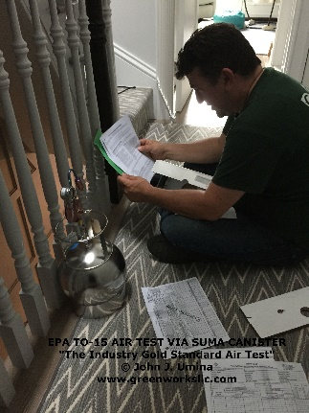
The Science of “Sniffing”
Like a fine wine, we tend to sniff the bouquet of wine in the glass to get an idea of what we are about to taste. So goes our environments where the aroma of the home helps us distinguish from normal ecology to not so-normal conditions. While odors help us immensely, they are just part of the process we follow assessing environments.
The Odor Rule
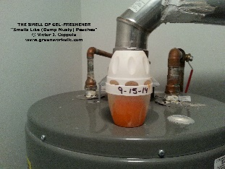
A good rule of thumb with odors in your home – if the leftovers in the refrigerator smelled like your musty basement, would you eat them? Probably not. So what makes it ok to breath them!

Odor in Your Home
Got a damp-musty basement type smell; a sweaty-sock locker-room type aroma or a musky-animal-like odor? GreenWorks can help!
Odor Investigative Services
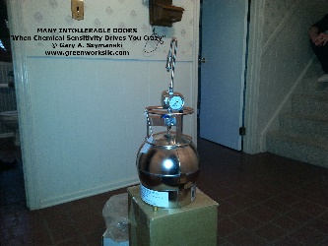
- VOC Investigations
- Aroma Investigations
- Material Testing
- Expert testimony
- Vapor Intrusion
- Formaldehyde Testing
- Sweaty-Sock-Syndrome
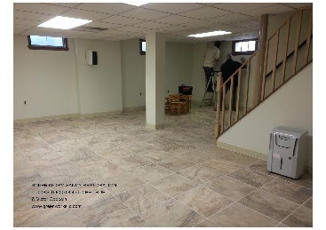
- Musty Smell, Organic Aroma, Biological Odor, Chemical Vapors, Soil Gases
