Chronic Inflammatory Response Syndrome (CIRS) and the Impact of EnviroBiotics

# Understanding Chronic Inflammatory Response Syndrome (CIRS)

Chronic Inflammatory Response Syndrome (CIRS) is a progressive, often debilitating condition resulting from an abnormal immune response to toxins produced by mold, bacteria, and other biotoxins frequently found in water-damaged buildings (WDBs). Unlike typical allergies, CIRS is rooted in innate immune system dysfunction, which can trigger a cascade of inflammatory responses throughout multiple systems of the body. Over time, this can lead to chronic illness and a significant decline in quality of life.

## Who Is Affected?

Those genetically predisposed—particularly individuals with specific HLA-DR gene types—are at higher risk of developing CIRS. This condition does not discriminate by age or gender and has been observed in children, adults, and the elderly. Populations most affected include individuals spending significant time in buildings with poor ventilation, visible mold, or a history of water intrusion. Common sources include schools, office buildings, public housing, and flood-damaged homes.

# Impact of EnviroBiotics on Mold Contamination in a CIRS-Affected Environment

To evaluate the effectiveness of EnviroBiotics Environmental Probiotics in reducing harmful mold levels, two ERMI and HERTSMI-2 tests were conducted on the same living space in Bloomingdale, IL—once before treatment and once approximately one months after application. These tests provide quantitative data about the presence of mold species known to exacerbate symptoms in CIRS patients.

## Key Toxic Molds Monitored (Associated with CIRS Relapse)

|  |  |
| --- | --- |
| Mold Species | Role in CIRS |
| Stachybotrys chartarum | Produces potent mycotoxins that impair neurological and immune function. |
| Chaetomium globosum | Triggers inflammation and produces mycotoxins harmful to respiratory and cellular health. |
| Aspergillus versicolor | Linked to neurotoxicity, immune suppression, and chronic inflammation. |

## Results Summary

- Stachybotrys chartarum reduced by 87%  
- Chaetomium globosum reduced by 91%  
- Aspergillus versicolor reduced by 26%  
  
It is important to note that while certain less pathogenic molds showed minor increases, they are not associated with serious health risks and are not known to trigger CIRS.

## Visual Impact of EnviroBiotics Treatment

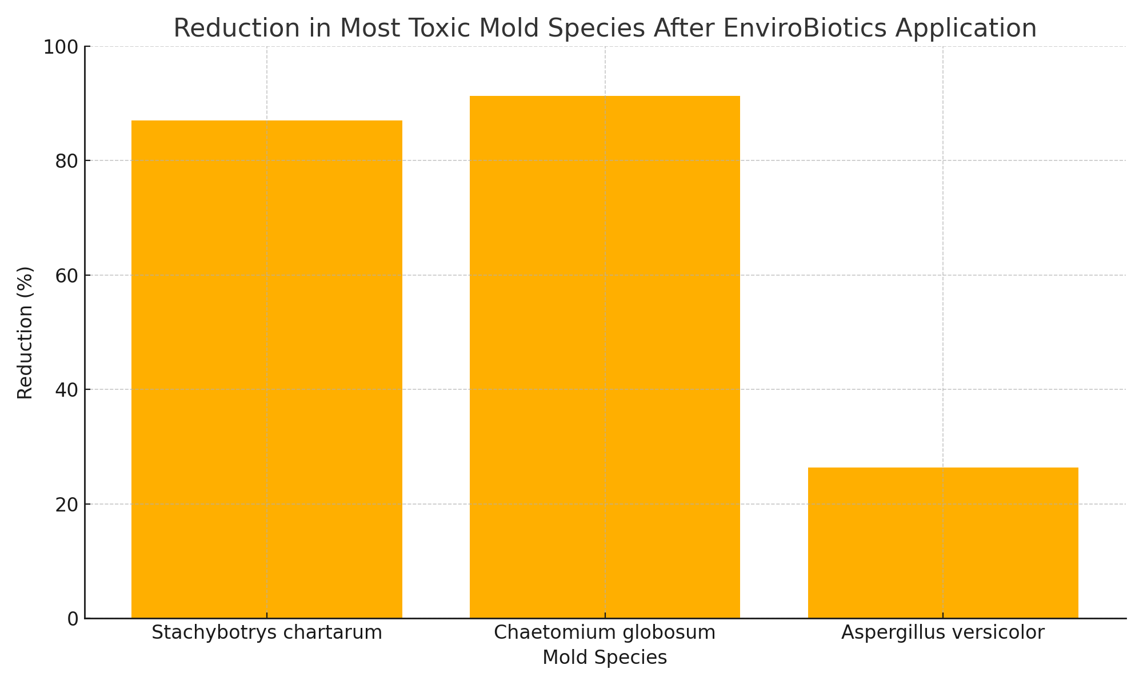

# Conclusion

The results of this case study demonstrate the remarkable effectiveness of EnviroBiotics Environmental Probiotics in significantly reducing the presence of toxic mold species most dangerous to CIRS sufferers. In particular, species like Stachybotrys chartarum and Chaetomium globosum—both known for their mycotoxin production and strong association with immune system dysregulation—saw dramatic reductions in spore equivalence levels.

These findings are especially significant given the limited treatment options available for individuals with CIRS, many of whom rely heavily on environmental remediation as part of their healing process. Traditional chemical cleaning methods often fail to address the microbial biofilm and dormant spores that persist in indoor spaces. EnviroBiotics offer a proactive and natural method of not just suppressing, but actively displacing harmful microbes with a beneficial probiotic ecology that supports long-term environmental health.

For patients struggling with CIRS, environments treated with EnviroBiotics may represent a safer path to recovery, helping to prevent symptom relapse and improve daily function. This natural, non-toxic approach may also be suitable for homes, schools, offices, and medical facilities seeking a safe alternative to chemical remediation.

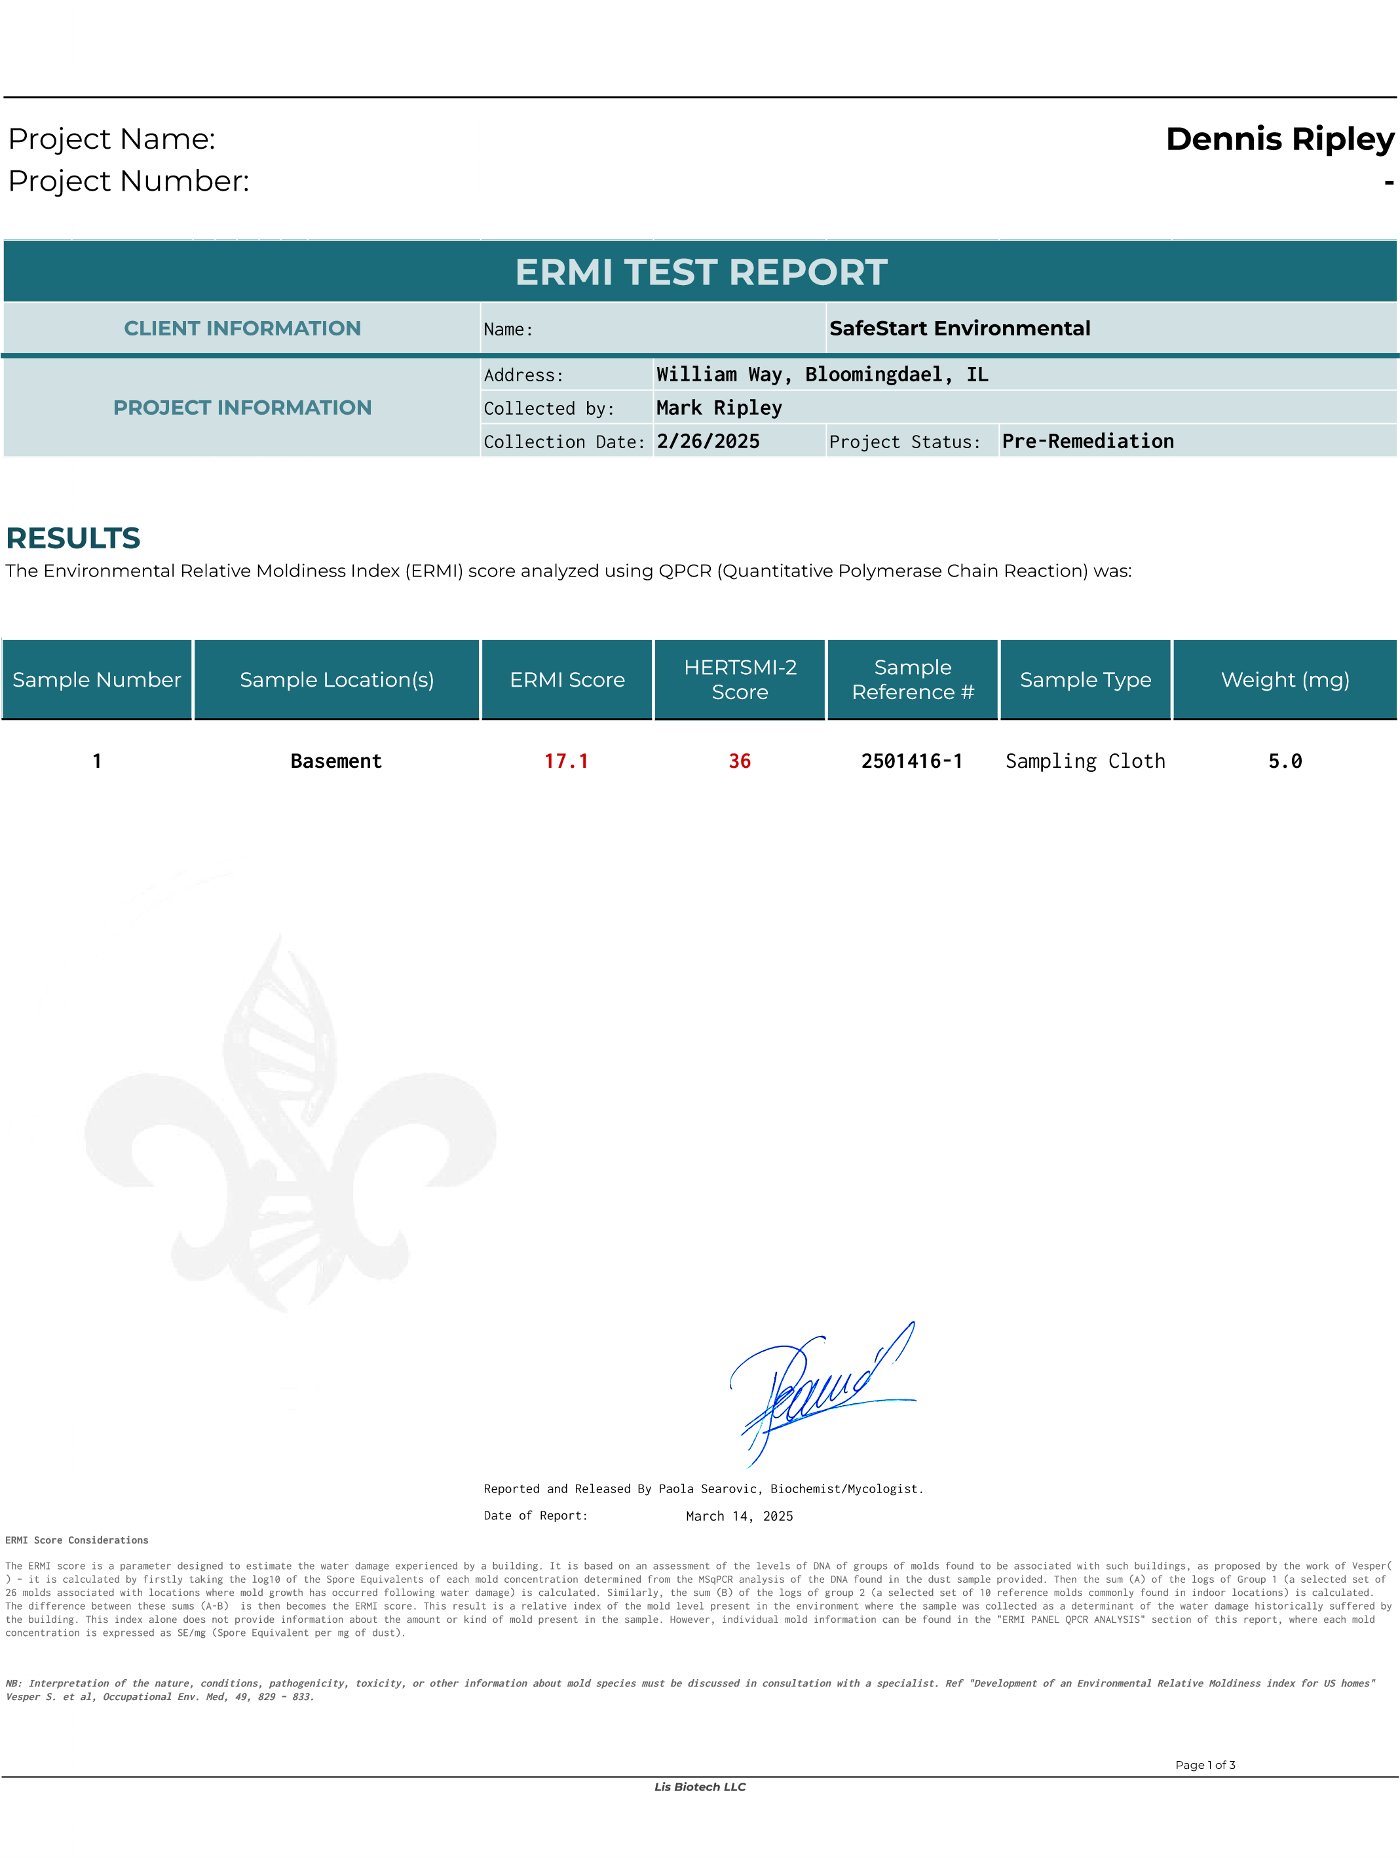4242 Medical Drive Ste 7325, San Antonio Tx 78229 +1 (210) 310 - 3089 www.lisbiotech.com

**DETAILED ANALYSIS AND SUPPORT INFORMATION**

**1. ERMI PANEL QPCR ANALYSIS**

The DNA extracted was used to evaluate the presence of 36 environmental molds considered in the ERMI panel by QPCR. The amount of amplified DNA by QPCR is proportional to the Spore Equivalent (SE). The ERMI score was calculated on the base of SE per mg of sample (SE/mg).

|  |  |  |
| --- | --- | --- |
| **Water Damage Molds - Group 1 (G1)** | | |
| **Species** | **SE/mg** | **Fold** |
| *Aspergillus flavus*  *Aspergillus fumigatus*  *Aspergillus niger*  *Aspergillus ochraceus* | **4**  **2**  **2**  **85** | 2  1  1  **42** |
| *Aspergillus penicillioides*  *Aspergillus restrictus*  *Aspergillus sclerotiorum*  *Aspergillus sydowii Aspergillus unguis* | **232**  **2**  **2**  **6,189**  **24** | 3  1  1  **2,063**  **12** |
| *Aspergillus versicolor* | **657** | **328** |
| *Aureobasidium pullulans* | **304** | 1 |
| *Chaetomium globosum* | **507** | **254** |
| *Cladosporium sphaerospermum*  *Eurotium amstelodami Paecilomyces variotii* | **15**  **492**  **55** | 1  3  **28** |
| *Penicillium brevicompactum* | **514** | **103** |
| *Penicillium corylophilum*  *Penicillium crustosum*  *Penicillium purpurogenum*  *Penicillium spinulosum Penicillium variabile*  *Scopulariopsis brevicaulis*  *Scopulariopsis chartarum* | ND  **3,151**  ND  **8**  **3**  **41**  **13** | 0  **3,151**  0 8  1  **20**  6 |
| *Stachybotrys chartarum* | **247** | **123** |
| *Trichoderma atroviride* | **21** | **10** |
| *Wallemia sebi* | **7** | 0 |
| ***Sum log G1* 39.9** | | |
| **Commom Indoor Molds - Group 2 (G2)** | | |
| *Acremonium strictum*  *Alternaria alternata*  *Aspergillus ustus*  *Cladosporium cladosporioides 1*  *Cladosporium cladosporioides 2*  *Cladosporium herbarum*  *Epicoccum nigrum*  *Mucor racemosus*  *Penicillium chrysogenum*  *Rhizopus stolonifer* | **4**  **782**  **45**  **2,963**  **7**  **279**  **12,577**  **705**  **7,635**  **1** | 1  **22 23**  9  2  9  **107**  **47**  **1,527**  1 |
| ***Sum log G2*** | **22.8** | |
| **ERMI Score (Sum logG1 - Sum logG2)** | **17.1** | |
| **Level of moldiness** | **Q4** | |
| *Internal Control Geotrichum Ct:* | *18.35* | |
|  | | |
| *The mold Geotrichum was included in the process (Geo batch #424208) to verify a successful DNA extraction from dust.*  *Accepted amplification value for the control* Geotrichum *Ct: <=19.5*  *Ct >19.5 Indicate the sample contains substances that cause the inhibition of the Taq Polymerase activity and therefore the qPCR results could be altered.*  To exclude problems with the enzyme activity or any failure with the reagents involved in the PCR reaction, an additional control was used (AmpPC) as a Positive Control during the qPCR reaction.  *Accepted amplification value for the control* AmpPC *Ct: <=19.5* ***AmpPC Ct:* 16.41**  Values <19.5 for AmpPC and >19.5 for Geotrichum confirm inhibition contains in sample. | | |

March 14, 2025 Page 2 of 3

|  |  |  |  |  |  |
| --- | --- | --- | --- | --- | --- |
| *Mold detected in concentration less than 0.5 SE/mg* ND = Not Detected  (*) ERMI molds highlated in red are ten fold of the geometric mean of the corresponding mold on the 2007 USA survey of molds.  Mold species (highlighted in yellow) known for mycotoxins production. **"Mycotoxins can cause a variety of adverse health effects and pose a serious health threat humans. The adverse health effects of mycotoxins range from acute poisoning to long-term effects such as immune deficiency and cancer (WHO)".** | | | | | |
| **2. SUPPORT INFORMATION**  a. ERMI score was developed by the US government for environmental mold safety, the following score table is a general reference of the environmental moldiness. | | | | | |
| **Level** | **ERMI Value** | **Moldiness Index** | |  | |
| **Q 1** | **Less than -4** | **Low Relative** | |
| **Q 2** | **-4 to < 0** | **Low - Medium Relative** | |
| **Q 3** | **0 to < 5** | **Medium- High Relative** | |
| **Q 4** | **> 5** | **High Relative** | |
| b. The **HERTSMI-2 (H-2)** score was calculated from the ERMI results obtained for the sample, and it was found to be: | | | | | |
| **Species** | | **SE/mg** | | **Points** |  |
| ***Aspergillus penicillioides*** | | 232 | | **6** |
| ***Aspergillus versicolor*** | | 657 | | **10** |
| ***Chaetomium globosum*** | | 507 | | **10** |
| ***Stachybotrys chartarum*** | | 247 | | **10** |
| ***Wallemia sebi*** | | 7 | | **0** |
| **HERTSMI-2 Score** | | **36** | | |  |
| **Level** | **H-2 Value** | | **Comment** | | |
| **1** | **< 11** | | Statistically safe for re-entry for those with CIRS | | |
| **2**  **3** | **11 to 15 > 15** | | Borderline. Further remediation first and re-test before re-entry Dangerous for those with CIRS. Do not enter. | | |
| **HERTSMI-2 Score Considerations**  HERTSMI-2 is a panel originated by Dr Shoemaker based on the detection and quantitation of the 5 molds, also determined by MSqPCR. Each mold is given a weighted value, depending on the abundance of the mold. The sum of these 5 values is then tallied, and interpreted in accordance with a published table( ). The HERTSMI-2 score reflects the potential that a sufferer of Chronic Inflammatory Response Syndrome (CIRS), who returns to the location where the sample was collected, may relapse. The score allocated to the molds in determining the HERTSMI-2 score does not provide information about the abundance of a mold or the degree of moldiness of a location. As with the ERMI, patients with CIRS acquired after exposure to the interior environment of a water-damaged building with toxigenic organisms, including but not limited to fungi, also could result from exposure to bacteria, including Actinobacteria and Mycobacteria, as well as inflammagens such as endotoxins, mycotoxins and other biotoxigenic contaminants.  **NB: HERTSMI-2 analysis cannot provide guarantees that HERTSMI-2 scores below/close to 11 are safe for habitation because some individuals are extremely susceptible to inflammation from exposure to Water-Damaged Building. A low HERTSMI-2 score possibly is not sensitive enough to show all areas of a given building. HERTSMI-2 analysis/score does not replace careful observation of symptoms and lab results obtained following re-exposure.**   1. In case of possible health problems related to environmental molds, please consult your doctor for advice to interpret the ERMI results. 2. Please consult a remediator or consultant expert in indoor molds for further assistance related with your ERMI results.   March 14, 2025 Page 3 of 3 | | | | | |

|  |  |  |  |  |  |  |  |  |  |  |  |  |
| --- | --- | --- | --- | --- | --- | --- | --- | --- | --- | --- | --- | --- |
| Project Name: **Ripley**  Project Number: **-** | | | | | | | | | | | | |
|  |  |  |  |  |  |  |  |  |  |  |  |  |
| **ERMI TEST REPORT** | | | | | | | | | | | | |
| **CLIENT INFORMATION** | | | | | | | | Name: | | **SafeStart Environmental** | | |
| **PROJECT INFORMATION** | | | | | | | | Address: | **232 William Way, Bloomingdale, IL** | | | |
| Collected by: | **Mark Ripley** | | | |
| Collection Date: | **5/16/2025** | Project Status: | **Progress** | |
|  |  |  |  |  |  |  |  |  |  |  |  |  |
|  |  |  |  |  |  |  |  |  |  |  |  |  |
|  |  |  |  |  |  |  |  |  |  |  |  |  |
| **RESULTS**  The Environmental Relative Moldiness Index (ERMI) score analyzed using QPCR (Quantitative Polymerase Chain Reaction) was: | | | | | | | | | | | | |
| Sample Number | | Sample Location(s) | | | | | | ERMI Score | HERTSMI-2  Score | Sample Reference # | Sample Type | Weight (mg) |

**1 Basement 19.9** **28**

**2501993-1**

Sampling Cloth

**5.2**



# Reported and Released By Paola Searovic, Biochemist/Mycologist. Date of Report: May 29, 2025

The ERMI score is a parameter designed to estimate the water damage experienced by a building. It is based on an assessment of the levels of DNA of groups of molds found to be associated with such buildings, as proposed by the work of Vesper( ) – it is calculated by firstly taking the log10 of the Spore Equivalents of each mold concentration determined from the MSqPCR analysis of the DNA found in the dust sample provided. Then the sum (A) of the logs of Group 1 (a selected set of 26 molds associated with locations where mold growth has occurred following water damage) is calculated. Similarly, the sum (B) of the logs of group 2 (a selected set of 10 reference molds commonly found in indoor locations) is calculated. The difference between these sums (A-B) is then becomes the ERMI score. This result is a relative index of the mold level present in the environment where the sample was collected as a determinant of the water damage historically suffered by the building. This index alone does not provide information about the amount or kind of mold present in the sample. However, individual mold information can be found in the "ERMI PANEL QPCR ANALYSIS" section of this report, where each mold concentration is expressed as SE/mg (Spore Equivalent per mg of dust).

### *NB: Interpretation of the nature, conditions, pathogenicity, toxicity, or other information about mold species must be discussed in consultation with a specialist. Ref "Development of an Environmental Relative Moldiness index for US homes"* Vesper S. et al, Occupational Env. Med, 49, 829 – 833.

Page 1 of 3

***Lis Biotech LLC***

4242 Medical Drive Ste 7325, San Antonio Tx 78229 +1 (210) 310 - 3089 [www.lisbiotech.com](http://www.lisbiotech.com/)

|  |  |  |  |  |  |  |  |  |  |  |  |  |
| --- | --- | --- | --- | --- | --- | --- | --- | --- | --- | --- | --- | --- |
|  |  |  |  |  |  |  |  |  |  |  |  |  |
| **DETAILED ANALYSIS AND SUPPORT INFORMATION**  **1. ERMI PANEL QPCR ANALYSIS**  The DNA extracted was used to evaluate the presence of 36 environmental molds considered in the ERMI panel by QPCR. The amount of ampliﬁed DNA by QPCR is proportional to the Spore Equivalent (SE). The ERMI score was calculated on the base of SE per mg of sample (SE/mg). | | | | | | | | | | | | |
| **Water Damage Molds - Group 1 (G1)** | | | | | | | | | | | | |
| **Species** | | | | | | | **SE/mg** | | | **Fold** | | |
| *Aspergillus ﬂavus Aspergillus fumigatus Aspergillus niger*  *Aspergillus ochraceus* | | | | | | | **28**  **9**  **5**  **62** | | | **14**  3  1  **31** | | |
| *Aspergillus penicillioides Aspergillus restrictus Aspergillus sclerotiorum Aspergillus sydowii*  *Aspergillus unguis* | | | | | | | **600**  **16**  **10**  **525**  **7** | | | 7  8  5  **175**  4 | | |
| *Aspergillus versicolor* | | | | | | | **484** | | | **242** | | |
| *Aureobasidium pullulans* | | | | | | | **252** | | | 1 | | |
| *Chaetomium globosum* | | | | | | | **44** | | | **22** | | |
| *Cladosporium sphaerospermum*  *Eurotium amstelodami Paecilomyces variotii* | | | | | | | **70**  **478**  **33** | | | 5  3  **16** | | |
| *Penicillium brevicompactum* | | | | | | | **344** | | | **69** | | |
| *Penicillium corylophilum Penicillium crustosum Penicillium purpurogenum Penicillium spinulosum Penicillium variabile Scopulariopsis brevicaulis*  *Scopulariopsis chartarum* | | | | | | | **10**  **542**  ND  **2**  **17**  **13**  **23** | | | 5  **542**  0  2  6  6  **12** | | |
| *Stachybotrys chartarum* | | | | | | | **32** | | | **16** | | |
| *Trichoderma atroviride* | | | | | | | **19** | | | **10** | | |
| *Wallemia sebi* | | | | | | | **21** | | | 1 | | |
| ***Sum log G1*** **40.6** | | | | | | | | | | | | |
| **Commom Indoor Molds - Group 2 (G2)** | | | | | | | | | | | | |
| *Acremonium strictum Alternaria alternata Aspergillus ustus Cladosporium cladosporioides 1*  *Cladosporium cladosporioides 2 Cladosporium herbarum Epicoccum nigrum*  *Mucor racemosus*  *Penicillium chrysogenum Rhizopus stolonifer* | | | | | | | **27**  **98**  **104**  **1,090**  **11**  **371**  **1,942**  **122**  **1,561**  **1** | | | 7  3  **52**  3  3  **12**  **17**  8  **312**  1 | | |
| ***Sum log G2*** | | | | | | | **20.8** | | | | | |
| **ERMI Score (Sum logG1 - Sum logG2)** | | | | | | | **19.9** | | | | | |
| **Level of moldiness** | | | | | | | **Q4** | | | | | |
| *Internal Control Geotrichum Ct:* | | | | | | | *18.35* | | | | | |
|  | | | | | | | | | | | | |
| *The mold Geotrichum was included in the process (Geo batch #424208) to verify a successful DNA extraction from dust. Accepted ampliﬁcation value for the control* Geotrichum *Ct: <=19.5*  *Ct >19.5 Indicate the sample contains substances that cause the inhibition of the Taq Polymerase activity and therefore the qPCR results could be altered.*  To exclude problems with the enzyme activity or any failure with the reagents involved in the PCR reaction, an additional control was used (AmpPC) as a Positive Control during the qPCR reaction.  *Accepted ampliﬁcation value for the control* AmpPC *Ct: <=19.5* ***AmpPC Ct:*** **16.41**  Values <19.5 for AmpPC and >19.5 for Geotrichum conﬁrm inhibition contains in sample. | | | | | | | | | | | | |

May 29, 2025 Page 2 of 3



*Mold detected in concentration less than 0.5 SE/mg* ND = Not Detected (*) ERMI molds highlated in red are ten fold of the geometric mean of the corresponding mold on the 2007 USA survey of molds.

Mold species (highlighted in yellow) known for mycotoxins production. **"Mycotoxins can cause a variety of adverse health effects and pose a serious health threat humans. The adverse health effects of mycotoxins range from acute poisoning to long-term effects such as immune deﬁciency and cancer (WHO)".**

1. **SUPPORT INFORMATION**
   1. ERMI score was developed by the US government for environmental mold safety, the following score table is a general reference of the environmental moldiness.

|  |  |  |  |
| --- | --- | --- | --- |
| **Level** | **ERMI Value** | **Moldiness Index** |  |
| **Q 1** | **Less than -4** | **Low Relative** |
| **Q 2** | **-4 to < 0**  **0 to < 5** | **Low - Medium Relative**  **Medium- High Relative** |
| **Q 3** |
| **Q 4** | **> 5** | **High Relative** |

* 1. The **HERTSMI-2 (H-2)** score was calculated from the ERMI results obtained for the sample, and it was found to be:

|  |  |  |  |  |  |
| --- | --- | --- | --- | --- | --- |
| **Species** | | **SE/mg** | | **Points** |  |
| ***Aspergillus penicillioides*** | | 600 | | **10** |
| ***Aspergillus versicolor*** | | 484 | | **6** |
| ***Chaetomium globosum*** | | 44 | | **6** |
| ***Stachybotrys chartarum*** | | 32 | | **6** |
| ***Wallemia sebi*** | | 21 | | **0** |
| **HERTSMI-2 Score** | | **28** | | |  |
| **Level** | **H-2 Value** | | **Comment** | | |
| **1** | **< 11** | | Statistically safe for re-entry for those with CIRS | | |
| **2** | **11 to 15** | | Borderline. Further remediation ﬁrst and re-test before re-entry | | |
| **3** | **> 15** | | Dangerous for those with CIRS. Do not enter. | | |

## HERTSMI-2 Score Considerations

*HERTSMI-2 is a panel originated by Dr Shoemaker based on the detection and quantitation of the 5 molds, also determined by MSqPCR. Each mold is given a weighted value, depending on the abundance of the mold. The sum of these 5 values is then tallied, and interpreted in accordance with a published table( ). The HERTSMI-2 score reflects the potential that a sufferer of Chronic Inflammatory Response Syndrome (CIRS), who returns to the location where the sample was collected, may relapse. The score allocated to the molds in determining the HERTSMI-2 score does not provide information about the abundance of a mold or the degree of moldiness of a location. As with the ERMI, patients with CIRS acquired after exposure to the interior environment of a water-damaged building with toxigenic organisms, including but not limited to fungi, also could result from exposure to bacteria, including Actinobacteria and Mycobacteria, as well as inflammagens such as endotoxins, mycotoxins and other biotoxigenic contaminants.*

***NB: HERTSMI-2 analysis cannot provide guarantees that HERTSMI-2 scores below/close to 11 are safe for habitation because some individuals are extremely susceptible to inflammation from exposure to Water-Damaged Building. A low HERTSMI-2 score possibly is not sensitive enough to show all areas of a given building. HERTSMI-2 analysis/score does not replace careful observation of symptoms and lab results obtained following re-exposure.***

# In case of possible health problems related to environmental molds, please consult your doctor for advice to interpret the ERMI results.

* 1. Please consult a remediator or consultant expert in indoor molds for further assistance related with your ERMI results.

May 29, 2025 Page 3 of 3